Branching and Merging Visualization with Visual Studio Team Foundation Server 2017

Lab version: 15.0.26228.0

Last updated: 3/1/2017

**TABLE OF CONTENTS**

Overview 1

Prerequisites 1

About the Fabrikam Fiber Scenario 1

Exercise 1: Working with Team Foundation Server Code Branches 2

Task 1: Updating a Source Control Branch 2

Task 2: Branching and Merging Visualization 7

# Overview

* 1. In this lab, you will be introduced to the branching and merging visualization support in Visual Studio Team Foundation Server 2017. This support makes it much easier to understand a solution branch hierarchy and to propagate changes during the merge process.

## Prerequisites

* 1. In order to complete this lab you will need the Visual Studio 2017 virtual machine provided by Microsoft. For more information on acquiring and using this virtual machine, please see [this blog post](http://aka.ms/almvm).

## About the Fabrikam Fiber Scenario

* 1. This set of hands-on-labs uses a fictional company, Fabrikam Fiber, as a backdrop to the scenarios you are learning about. Fabrikam Fiber provides cable television and related services to the United States. They are growing rapidly and have embraced Windows Azure to scale their customer-facing web site directly to end-users to allow them to self-service tickets and track technicians. They also use an on-premises ASP.NET MVC application for their customer service representatives to administer customer orders.

In this set of hands-on labs, you will take part in a number of scenarios that involve the development and testing team at Fabrikam Fiber. The team, which consists of 8-10 people, has decided to use Visual Studio application lifecycle management tools to manage their source code, run their builds, test their web sites, and plan and track the project.

# Exercise 1: Working with Team Foundation Server Code Branches

* 1. In this exercise, you will learn about some of the code branching features in Team Foundation Server, as well as how to open a solution that corresponds to a specific code branch. In addition, this exercise will serve as the setup for a scenario where production code needs to be updated with changes that are ultimately merged through active branches in the system.

## Task 1: Updating a Source Control Branch

1. Log in as **Sachin Raj (VSALM\Sachin)**. All user passwords are **P2ssw0rd**.
2. Launch **Visual Studio 2017** from the taskbar and open **Team Explorer**. You should now be connected to the **FabrikamFiber** team project. If you are not automatically connected to the **FabrikamFiber** project, click the **Manage Connections** and then double-click the **FabrikamFiber** project to do so.

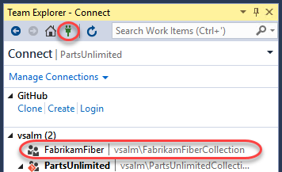

1. Open the **Source Control Explorer** window by selecting the Source Control Explorer tile.

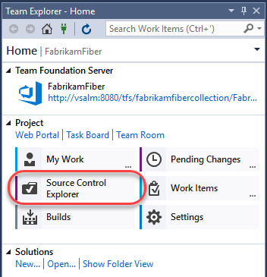

1. The **Fabrikam Fiber** project contains a main code base (under **Main**), a development code base (under **Dev**), as well as release branches (under **Releases**). Branches are first-class objects that are represented with their own icon in **Source Control Explorer**.

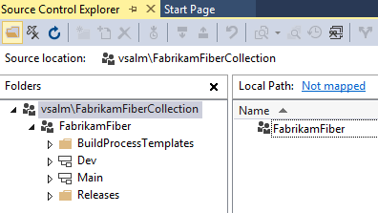

1. Expand the **Releases** node and right-click **Release1** to select **Advanced |Properties** from the context menu.

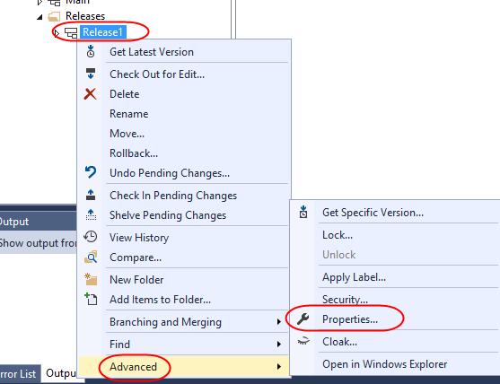

1. The **Properties** window provides general details like version and description, hierarchical relationship to other branches, and permissions.

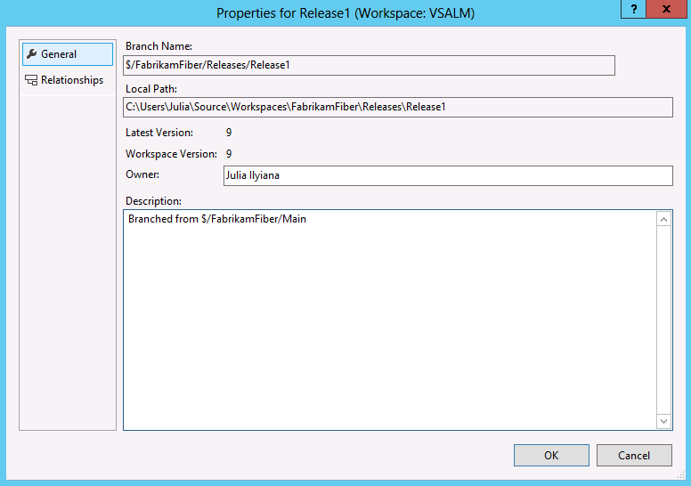

1. Press **Esc** to return to **Source Control Explorer**.
2. Expand the **Release1** branch node in the **Releases** folder and locate the **FabrikamFiber.CallCenter.sln** solution file in the **FabrikamFiber.CallCenter** folder. Double-click to open it.

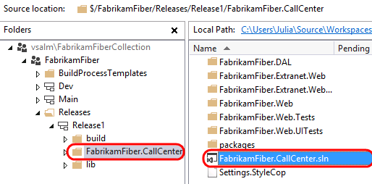

1. Rebuild the solution (**Build | Rebuild Solution** from the main menu).
2. Ensure that the **FabrikamFiber.Web** project is set as the startup project (**right-click** and select **Set as StartUp Project** in **Solution Explorer**).
3. Press **F5** to launch the Fabrikam Fiber intranet portal.

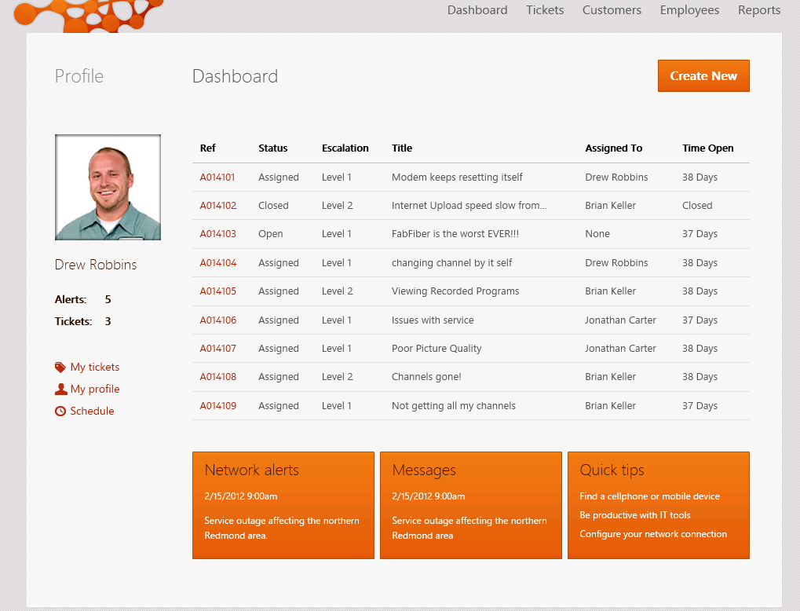

1. Imagine a scenario where the **Release1** branch represents the code that is currently running on the production web server. Management has decided that the non-functional links under the profile section on the left side of the page should be removed as soon as possible. We have decided to “fast track” this change by making the update directly to the **Release1** branch. Later, you will see how we can merge this change back to the **Dev** branch so that it becomes a part of the changes we’re working on for the next release.

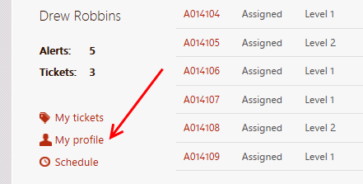

1. **Close** the **Internet Explorer** window and return to **Visual Studio**.
2. Our first task is to update the **Release1** branch and deploy the changes to the production web server. From **Solution Explorer**, open **FabrikamFiber.Web\Views\Shared\_Profile.cshtml**.
3. Comment out the **My tickets** link through the **Schedule** link as shown below.

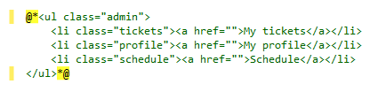

1. Press **F5** to launch the website and verify that the non-functional links are no longer displayed. For the purposes of this demonstration, assume that at this point we have successfully deployed the updated change to the production server.
2. **Close** the **Internet Explorer** window and return to **Visual Studio**.
3. Open **Team Explorer** and navigate to **Pending Changes**.

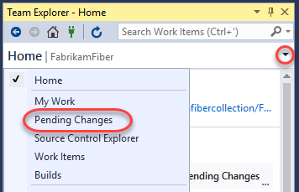

1. In the **Comment** field, enter **“removed non-functional links from profile”**, verify only **_Profile.cshtml** is changed, and click **Check In**. Select **Yes** if prompted to confirm check-in.

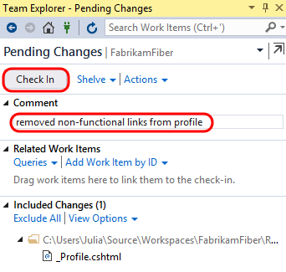

1. In the next task, we will merge the changes to the other branches.

## Task 2: Branching and Merging Visualization

* 1. In this task, you will learn how to visualize and track changesets while merging the changes that you made in the previous exercise.

1. In **Source Control Explorer**, right-click the **Release1** branch and select **View History** from the context menu. Note that the items in your history may vary from the screenshot below.

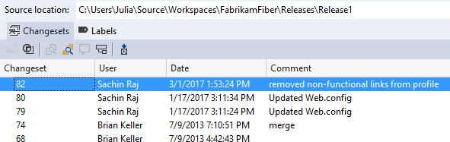

1. **Right-click** the changeset that you just checked in and select **Track Changeset** from the context menu.

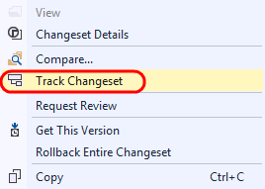

1. In the **Select Branches** window, change **Starting branch** to **Release1**. Click **Visualize** to see the current state of the changeset as it relates to the other branches.

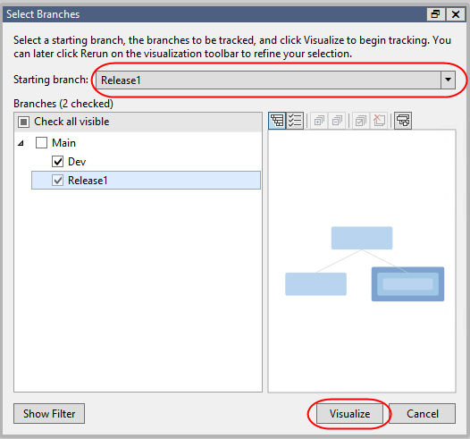

1. This visualization shows us that the changeset has been applied to **Release1** but not to **Dev**. It also makes it clear that in order to merge our changes into **Dev** we will need to merge with the **Main** branch first.

**Note:** Your changeset numbers may be different from those in the screenshots.

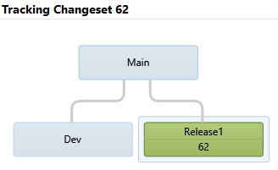

1. To perform the merge of this changeset and the Main branch, **drag and drop** the green **Release1** node onto the **Main** node. This will load the Source Control Merge Wizard.

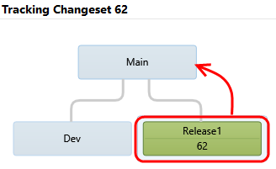

1. Ensure that the source branch to merge ends with “Release1” and the target branch ends with “Main”. Select the **Next** button to continue.

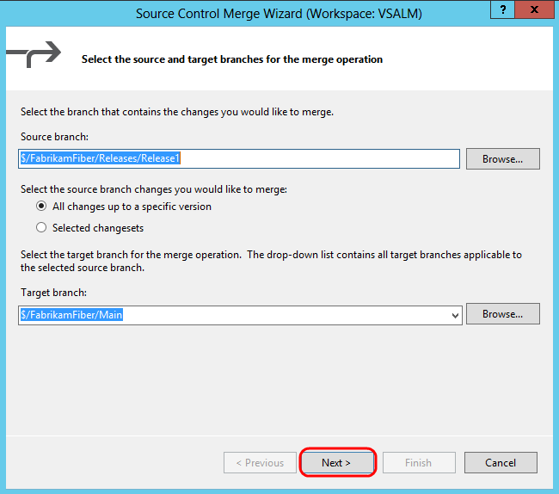

1. The next screen of the merge wizard specifies the version to merge. By default, you should see the changeset that you just checked in. Select the **Finish** button to perform the merge.

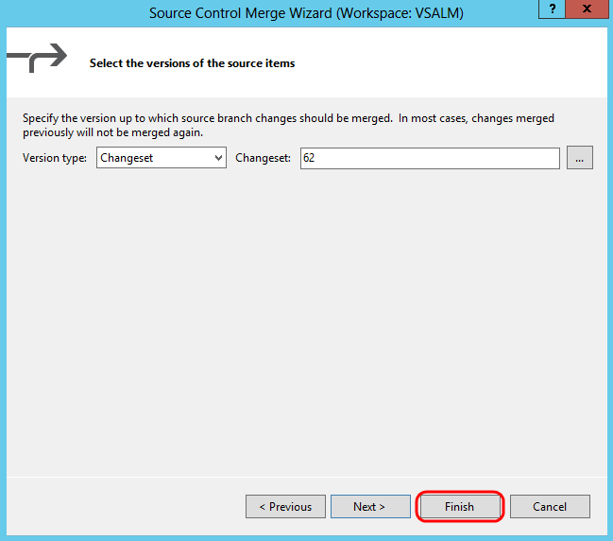

1. After the merge is complete, open **Team Explorer** and navigate to **Pending Changes**.



1. Note that **_Profile.cshtml** changed status for the **Main** code branch and is now “merge, edit”. The merge process is complete, but we still need to check in the changes.

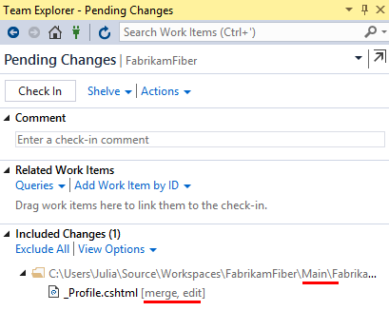

1. Add a **Comment** of **“Merging fast-tracked changes from Release to Main”** and then click **Check In** to finalize the merge. Select **Yes** if asked to confirm the check-in.

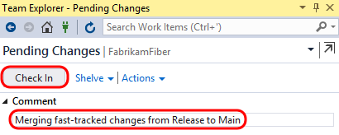

1. In the **Tracking Changeset** window, select the **Rerun** button to generate an updated view. You will need to click **Visualize** again when the **Select Branches** window appears.



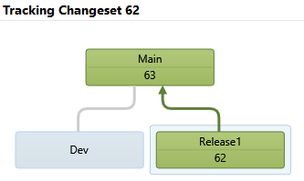

1. Next, merge the changeset from the **Main** branch with the **Dev** branch in the same manner as before by dragging and dropping to load the **Source Control Merge Wizard**.
2. Select **Next** followed by **Finish** to perform the merge process.
3. In the **Pending Changes** window, enter a **Comment** of **“Merged fast-tracked changes from Main to Dev”**.
4. Select the **Check In** button to finalize the merge with the Dev branch. Select **Yes** if asked to confirm the check-in.
5. In the **Tracking Changeset** window, click on the **Rerun** button to see the updated view.

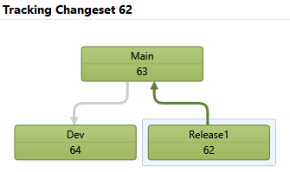

1. Another useful view is the Timeline Tracking view. Select the **Timeline Tracking** button to the left of the Hierarchy Tracking button to switch to this view. This shows the order in which the original changeset was merged with the other branches.



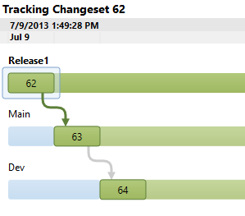

1. In **Solution Explorer**, navigate to and right-click **_Profile.cshtml** to select **Source Control | Annotate** from the context menu.
2. Scroll to the bottom of the annotated **_Profile.cshtml** file and locate the HTML that you previously commented out.
3. In the annotation column on the left-hand side, mouse over the recent changeset (it should show the date of the guest virtual machine). Note that the changeset path and comment refer to the Production branch where the original change was made.

